Ye Olde UNESCO Newsletter
This Newsletter is part of the school’s Erasmus project “Happy, Healthy, Wise and Wealthy”. All articles are about the days during the learning/teaching/training activities held at ZŠ UNESCO in Uherské Hradiště between the 2nd – 8th April 2022.
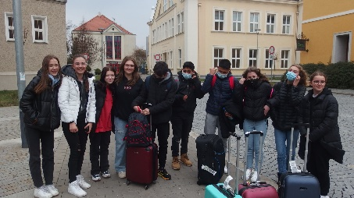
Day 1 – Saturday 2nd April
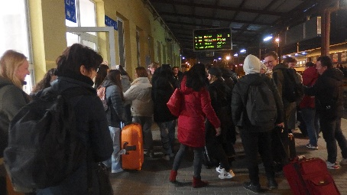
This is the day we had been waiting for as our guests were travelling to come and see us. As they were travelling at different time we slowly met them during the afternoon and evening. When they had arrived, we took them home so they could settle in and rest. With all projects there has to be a small problem. Our friends from Denmark had missed their connecting flight and were going to be delayed by over 24 hours. So, they got to do some extra sight-seeing in Warsaw – Poland.
Day 2 – Sunday 3rd April
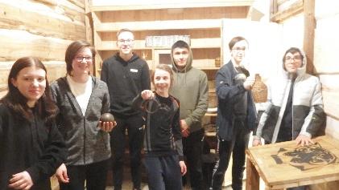
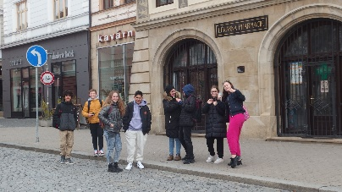
As the week was starting on a Sunday, activities had to be arranged for us. The teachers arranged for us to go geocaching and something called “Fort Boyard”. We started at 10 in the morning and were split into groups. The geocaching had been arranged by one of our teachers Jiří Silný. It was fun but we had to do a lot of walking, by doing this our new friends got to see the sights of the town. But, it was cold. We all took it in turns to do the “Fort Boyard” activity where we had to solve puzzles, this was really good as it was much warmer in side. The whole day was a competition and the winners (picture on right) got a 1600Kč voucher for KFC. At 15:30 we finished and all the teacher went on a trip to Velehrad, while we went home and did our own things.
Day 3 – Monday 4th April
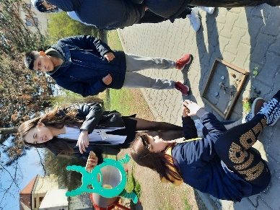
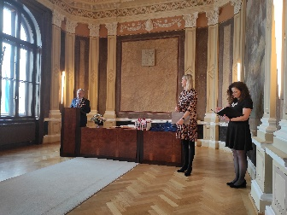
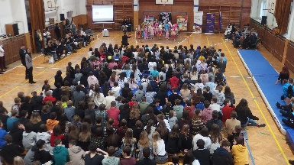
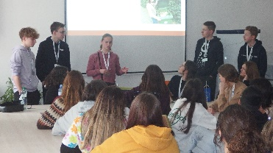
We all met at school at 8 and our friends from Denmark had finally arrived at 2 o’clock in the morning. So, this was a tough day for them. The first thing was the welcoming ceremony in the gym. There was some dancing and gymnastics and everyone was introduced to the some of the school. After this at 10 our new friends went to the Town Hall where everyone was welcomed by the Deputy Mayor and presents were given out. Then it was time for the workshops, this was where we were going to be making posters or some land art. While this was going on the teachers went on a guided tour of the school. At lunch time we went to the school canteen for a bit of lunch, what can we say about that? After lunch we gave some presentations about the mornings work and also listened to the presentations about recycling in different countries. After all the work in school we split into groups and did some different activities and had fun.
Day 4 – Tuesday 5th April
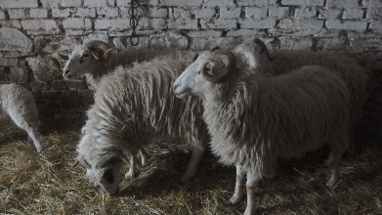
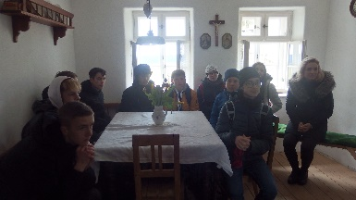
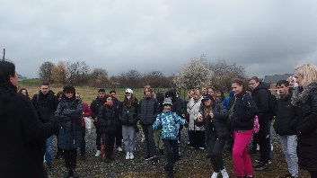
This was going to be a bad day as it was raining and we were going to have to go out walking. The first thing we did was to go the water treatment plant in Štepnice. OMG!!!! This was not fun as the smell around there was horrible. The guides were nice but most of us didn’t understand what they were saying. When we left there, everyone was happy as we could breathe again. Then it was the long walk up to Rochus. This was ok as the rain had stopped but it was windy and cold. We looked around the museum in groups and saw houses and things from the old days. The sheep were so cute, but Mr Mabbett thought the lamb looked tasty.

When we finished here it was a race to see who could get back to the school canteen for dinner. After dinner we had free time, some went swimming or played football. This was the best part of the day.
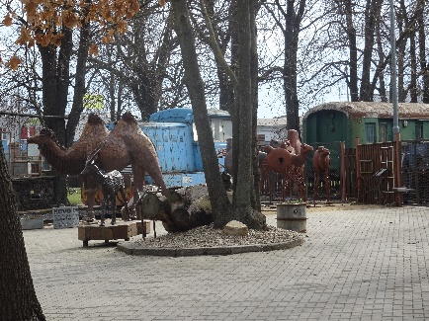
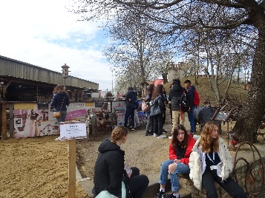
Day 5 – Wednesday 6th April
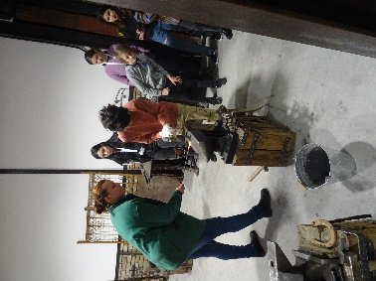
This day was a trip to Kovozoo, again we had to walk. This time the weather was ok and we didn’t get wet like the day before. We got there early and waited for a while then we had a ride on a little train to show us the workings of the metal recycling areas. This only took 15 minutes then it the time for a bit of fun. We were allowed to look at all things there and see the animals and old machinery. We were in groups for going to see the blacksmith show. Here, some of us made nails the way it was done in the old days. After a few hours of looking around and playing or just talking it was lunch time. Lunch was good, much better than the school canteen, then it was time to walk back to the school and the spend the rest of the afternoon doing our own thing.
Day 6 – Thursday 7th April
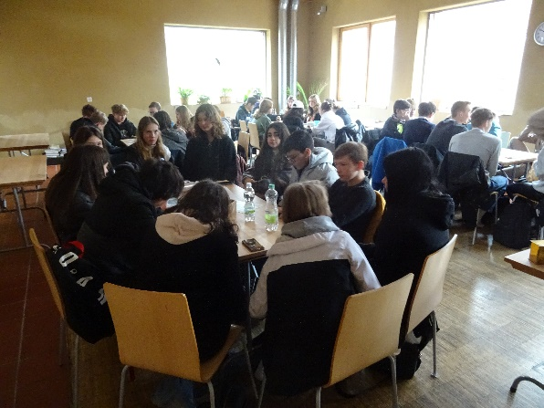
Today a trip with no walking, well that is what we thought. We went to Hostětin by bus. This is an eco-village, it is a project using technology to try and save the environment and help with global warming. We sit in a building which is meant to be energy efficient and some things explained to us about the way it was built. We also did some small projects on how to make the village self-sufficient. This means that they can survive without outside help. All very technical and boring for some of us. As the project involves the village, we had to go and see it. Guess what? This meant we had to walk again, OH NO!!! In the end the walk was ok but we did a lot of mud on our shoes. After this we went back to Bojkovice and had lunch in a restaurant, this was the best food of the week. Apart from the trips to KFC. When we got back to school we all to do different things as this was to be our last night.
Day 7 – Friday 8th April
This was the saddest part of the week as we had to say goodbye to our new friends we had shared the past week with in our homes. We hope they all enjoyed their time with us and hope to continue these great friendships. We wish everybody safe travels and good luck for the future. Also, we know some of us will see our friends again as we are going to travel to Denmark in a few weeks’ time.
We would like to thank our teachers Mrs Přikrylová and Mr Mabbett for all of their hard work in putting together a fantastic week for us and our friends from Denmark, Spain, the Netherlands and Portugal.
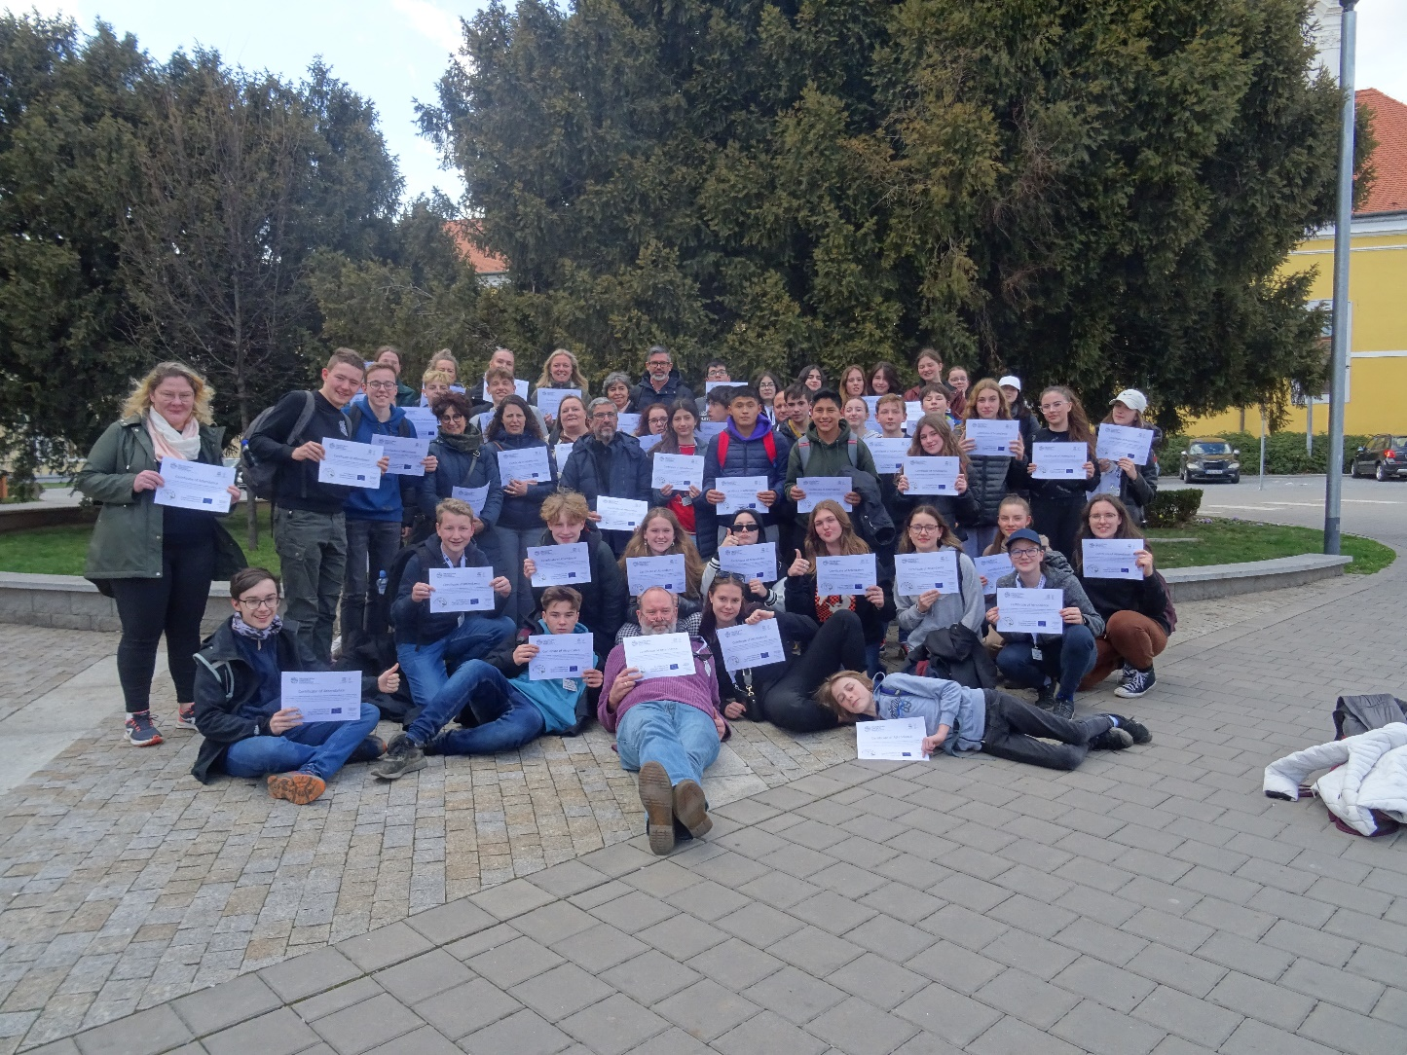
Thank you for coming from all at ZŠ UNESCO

